Q1. Write a program to replace a substring inside a string with other string ?
A1.
1.java

class Exercise_1 {

public static void main(String[] args) {
String str = "This is what it is.";
str = str.replace("is", "is not");
System.out.println(str);
}
}
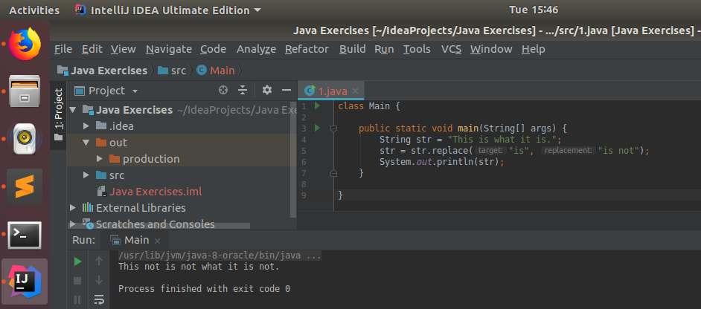

Q2. Write a program to find the number of occurrences of the duplicate words in a string and print them ?
A2.
2.java
import java.util.Scanner;

class Exercise_2 {

public static void main(String[] args) {

Scanner sc = new Scanner(System.in);
String str = sc.nextLine();

String[] words = str.split(" ");
int[] count = new int[words.length];

System.out.println("Number of duplicate words in the string are: ");

for (int i = 0; i < words.length - 1; i++) {

count[i] = 1;

for (int j = i + 1; j < words.length; j++) {

if (count[i] == -1)
break;

if (count[j] == -1)
continue;

if (words[i].equals(words[j])) {
count[i]++;
count[j] = -1;
}
}

if (count[i] > 1)
System.out.println(words[i] + ": " + count[i]);
}
}
}
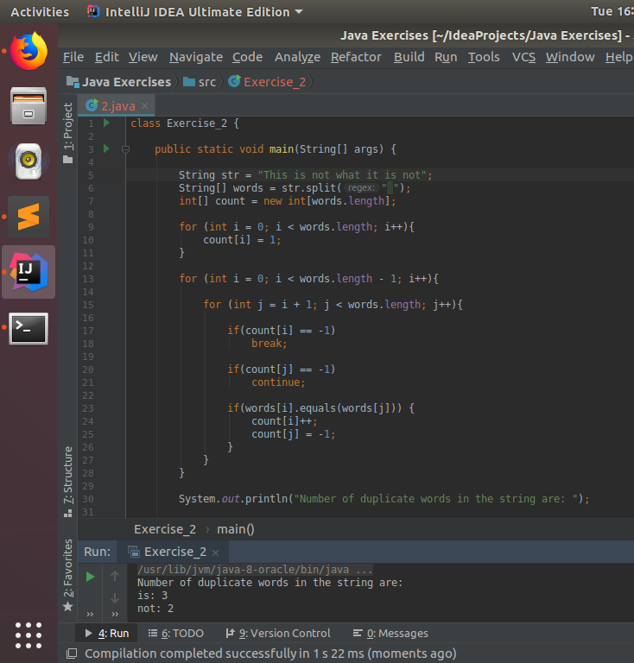

Q3. Write a program to find the number of occurrences of a character in a string without using loop?
A3.
3.java

import java.util.Scanner;

class Exercise_3 {

public static void main(String[] args) {

Scanner sc = new Scanner(System.in);
String str = sc.nextLine();
char c = sc.next().charAt(0);

int len_w_char = str.length();
int len_wo_char = str.replace(Character.toString(c), "").length();

int count = len_w_char - len_wo_char;

System.out.println("Number of occurences of '" + c + "' in the string are: " + count);
}
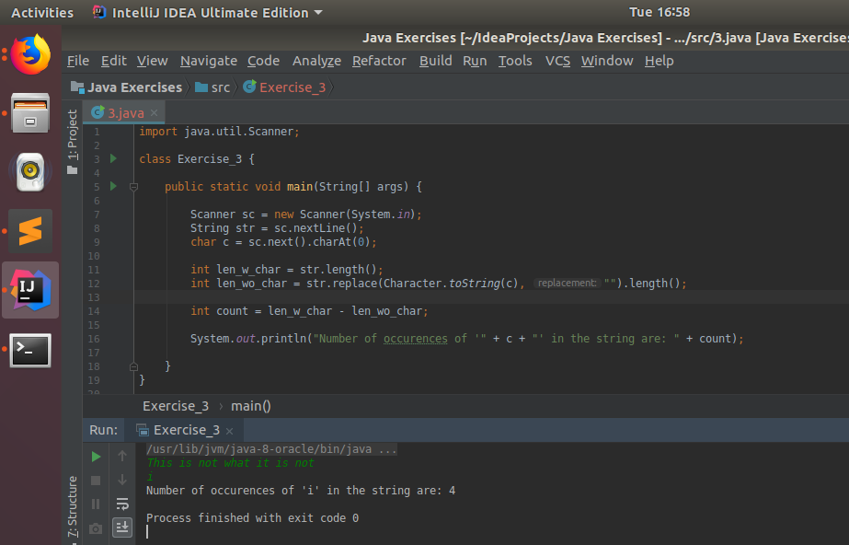
}

Q4. Calculate the number & Percentage Of Lowercase Letters,Uppercase Letters, Digits And Other Special Characters In A String
A4.
4.java
import java.util.Scanner;

class Exercise_4 {

public static void main(String[] args) {

Scanner sc = new Scanner(System.in);
String str = sc.nextLine();

char[] chars = str.toCharArray();

int lowcase = 0, uppcase = 0, digits = 0, spechars = 0;

for (int i = 0; i < chars.length; i++){

if(Character.isLowerCase(chars[i]))
lowcase++;

else if(Character.isUpperCase(chars[i]))
uppcase++;

else if(Character.isDigit(chars[i]))
digits++;

else
spechars++;

}

System.out.println("Percentage of characters");
System.out.println("Lowercase: " + (lowcase * 100.0 / chars.length) +
"%\nUppercase: " + (uppcase * 100.0 / chars.length) +
"%\nDigit: " + (digits * 100.0 / chars.length) +
"%\nSpecial Characters: " + (spechars * 100.0 / chars.length) + "%");
}
}

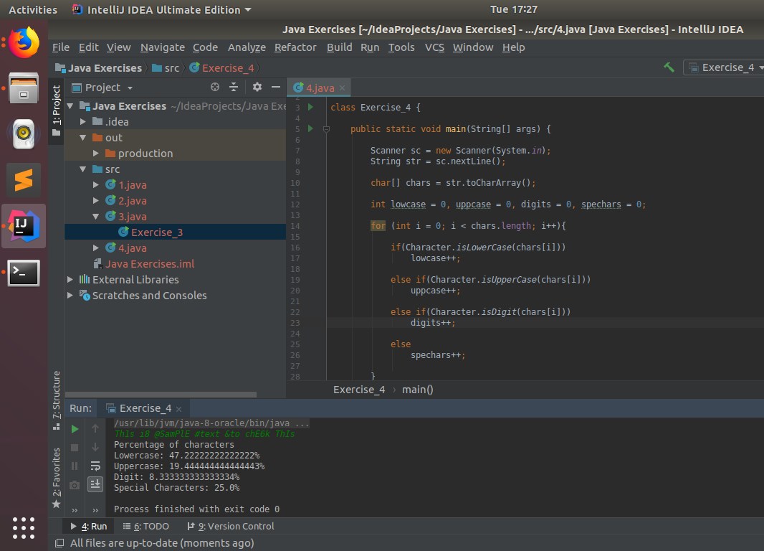

Q5. Find common elements between two arrays.
A5.
5.java

import java.util.ArrayList;
import java.util.Scanner;

class Exercise_5 {

public static void main(String[] args) {

Scanner sc = new Scanner(System.in);

System.out.println("Enter the sizes of the array (n1, n2):");
int n1 = sc.nextInt(), n2 = sc.nextInt();

int arr1[] = new int[n1], arr2[] = new int[n2];
ArrayList<Integer> commonele = new ArrayList<>();

System.out.println("Enter first array: ");
for (int i = 0; i < n1; i++)
arr1[i] = sc.nextInt();

System.out.println("Enter second array: ");
for (int i = 0; i < n2; i++)
arr2[i] = sc.nextInt();

for (int i = 0; i < n1; i++){
for (int j = 0; j < n2; j++){
if (arr1[i] == arr2[j]){

if (!commonele.contains(arr1[i]))
commonele.add(arr1[i]);
}
}
}

if (commonele.size() > 0)
for (int i = 0; i < commonele.size(); i++){
System.out.print(commonele.get(i) + " ");
}
}
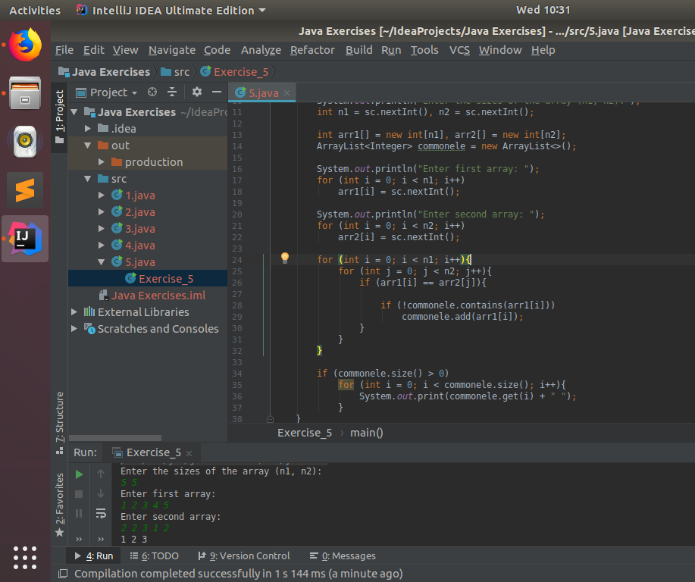
}

Q6. There is an array with every element repeated twice except one. Find that element
A6.
6.java
import java.util.Scanner;

class Exercise_6 {

public static void main(String[] args) {

Scanner sc = new Scanner(System.in);

System.out.println("Enter the size of the array: ");
int n = sc.nextInt();
int[] arr = new int[n];
int[] count = new int[n];

System.out.println("Enter the elements of the array: ");
for (int i = 0; i < n; i++)
arr[i] = sc.nextInt();

for (int i = 0; i < n; i++) {

int flag = 0;

for (int j = 0; j < n; j++) {
if (i != j && arr[i] == arr[j]) {
flag = 1;
break;
}
}

if (flag == 0) {
System.out.println("The element having single occurrence: " + arr[i]);
break;
}
}
}
}

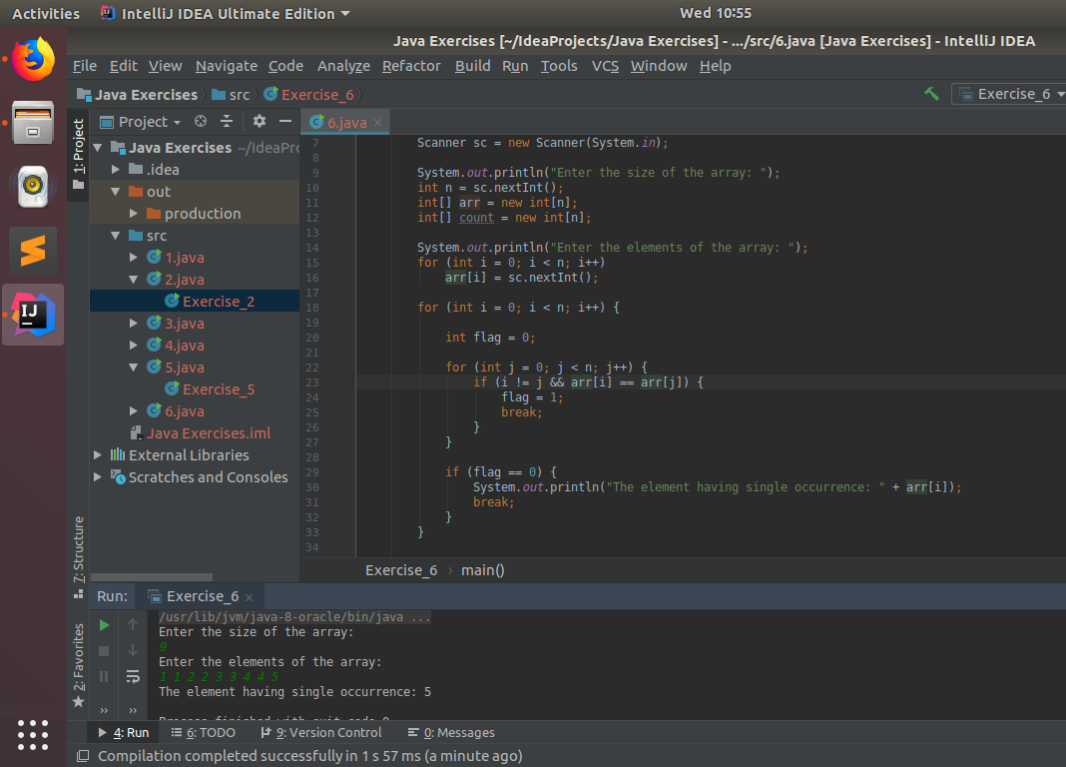

Q7. Write a program to print your Firstname,LastName & age using static block,static method & static variable respectively
A7.
7.java
class Exercise_7 {

static String blockFirstName;
static String blockLastName;
static int blockAge;

static String varFirstName = "Sunil";
static String varLastName = "Pal";
static int varAge = 49;

static{
blockFirstName= "Rajeev";
blockLastName = "Nigam";
blockAge = 50;
}

static void printinfo(){
System.out.println("\nStatic Method");
System.out.println("First Name: " + "Raju" + "\nLast Name: " + "Srivastava" + "\nAge: " + 48);
}

public static void main(String[] args) {

System.out.println("Static Block");
System.out.println("First Name: " + blockFirstName + "\nLast Name: " + blockLastName + "\nAge: " + blockAge);

printinfo();

System.out.println("\nStatic Variables");
System.out.println("First Name: " + varFirstName + "\nLast Name: " + varLastName + "\nAge: " + varAge);
}
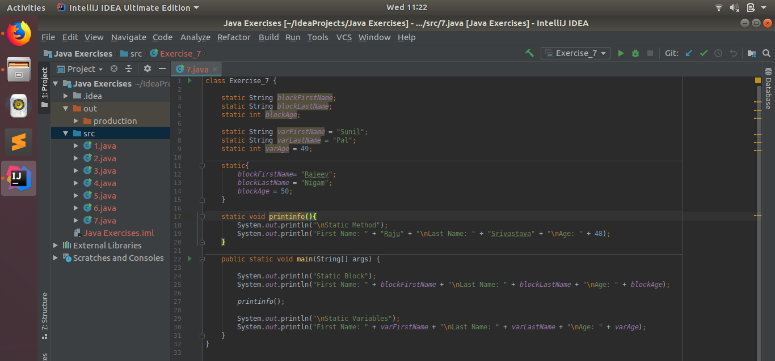
}
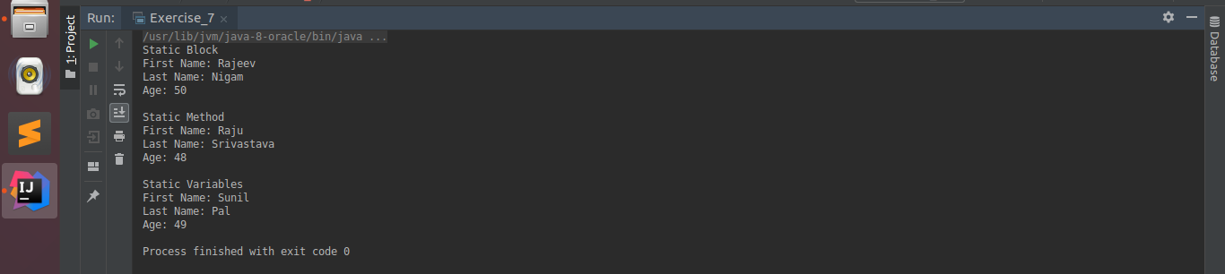

Q8. Write a program to reverse a string and remove character from index 4 to index 9 from the reversed string using String Buffer
A8.
8.java
import java.util.Scanner;

class Exercise_8 {

public static void main(String[] args) {

Scanner sc = new Scanner(System.in);

System.out.println("Enter the string: ");
StringBuffer str = new StringBuffer(sc.nextLine());

str = str.reverse().delete(4, 9);

System.out.println("Formatted string is: \n" + str);
}
}

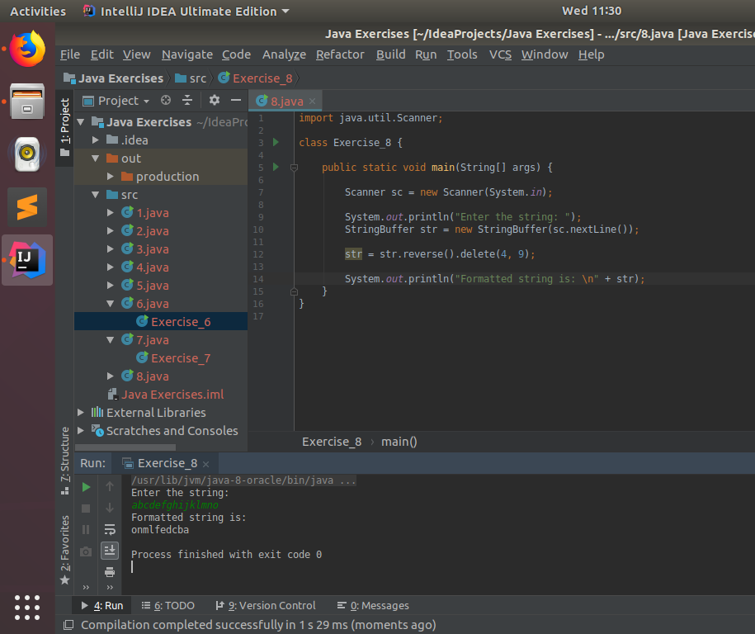

Q9.Write a program to display values of enums using a constructor & getPrice() method (Example display house & their prices)
A9.
9.java
enum houses{
OneBHK(25),
TwoBHK(35),
ThreeBHK(45);

int price;

houses(int price){
this.price = price;
}

int getPrice(){
return price;
}
}

class Exercise_9 {

public static void main(String[] args) {

System.out.println("Name and prices of enum 'houses':");
houses arr[] = houses.values();

for (houses house: arr)
System.out.println(house.name() + ": " + house.getPrice());
}
}
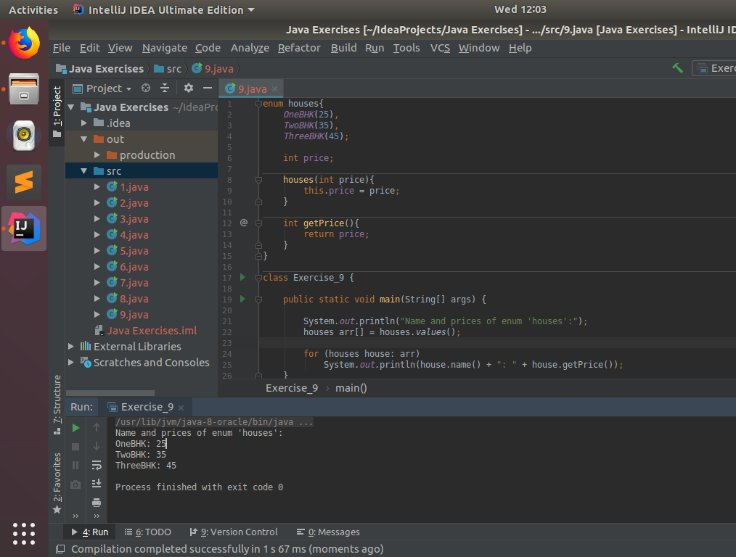

Q10.Write a single program for following operation using overloading
A) Adding 2 integer number
B) Adding 2 double
C) multiplying 2 float
D) multiplying 2 int
E) concate 2 string
F) Concate 3 String

A10.
10.java
class Exercise_10 {

static int add(int a, int b){return a + b;}

static double add(double a, double b){return a + b;}

static float multiply(float a, float b){return a * b;}

static int multiply(int a, int b){return a * b;}

static String concat(String a, String b){return a + b;}

static String concat(String a, String b, String c){return a + b + c;}

public static void main(String[] args) {

System.out.println(add(20, 30));
System.out.println(add(25.5, 31.1));
System.out.println(multiply(2, 3));
System.out.println(multiply(22.7f, 31.1f));
System.out.println(concat("abc", "def"));
System.out.println(concat("abc", "def", "ghi"));

}
}
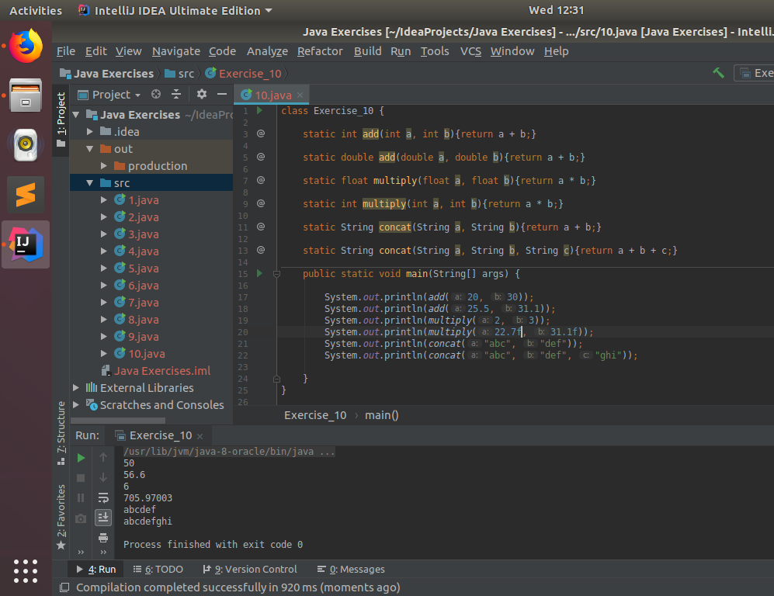

Q11.Create 3 sub class of bank SBI,BOI,ICICI all 4 should have method called getDetails which provide there specific details like rateofinterest etc,print details of every banks
A11.
11.java
class Bank {

String name;
double roi;

Bank(String name, double roi){
this.name = name;
this.roi = roi;
}

void getDetails(){
System.out.println("Name of the bank: " + name);
System.out.println("ROI of the bank: " + roi);
}
}

class SBI extends Bank{

SBI(){
super("SBI", 6.0);
}
}

class BOI extends Bank{

BOI(){
super("BOI", 5.5);
}
}

class ICICI extends Bank{

ICICI(){
super("ICICI", 7.0);
}
}

class Exercise_11{

public static void main(String[] args) {
SBI sbi = new SBI();
BOI boi = new BOI();
ICICI icici = new ICICI();

System.out.println("Calling getDetails() of SBI class object...");
sbi.getDetails();

System.out.println("Calling getDetails() of BOI class object...");
boi.getDetails();

System.out.println("Calling getDetails() of ICICI class object...");
icici.getDetails();
}
}

